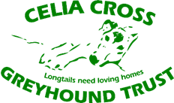­­

10 November 2018

## Rescue charity caring for dogs in Guildford has uncovered appalling conditions at kennels where up to 80 greyhounds were kept for racing.

The Celia Cross Greyhound Trust (CCGT) exposed horrific scenes after purchasing the kennels on Halloween. Hillside racing kennels were vacated just four days earlier. Sadly up to 80 greyhounds, who race at Brighton and Hove track, lived in these filthy, dilapidated kennels in the heart of the beautiful Surrey Hills.

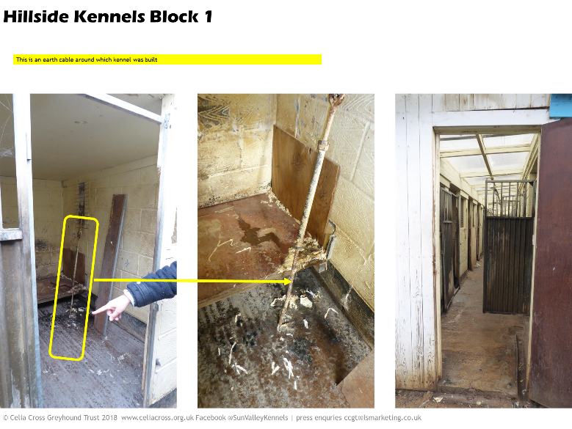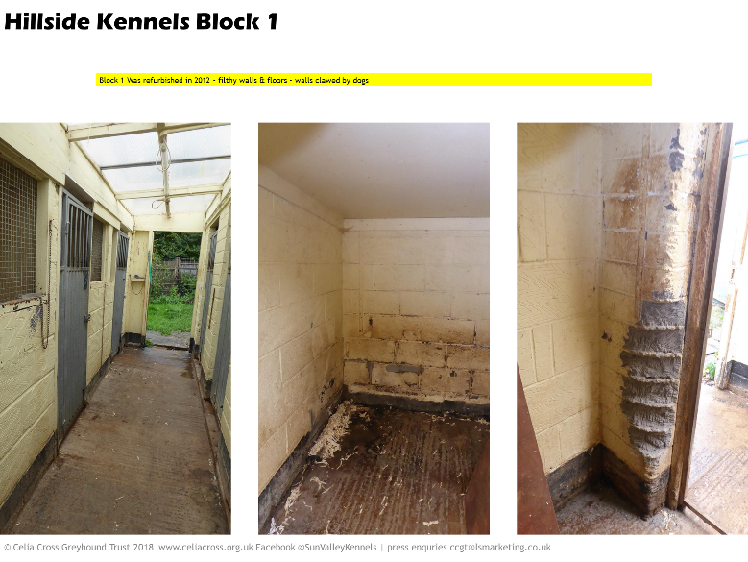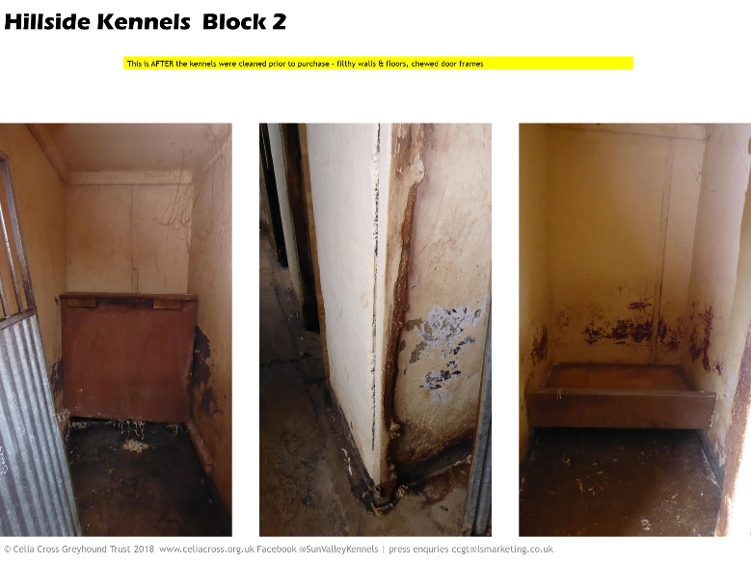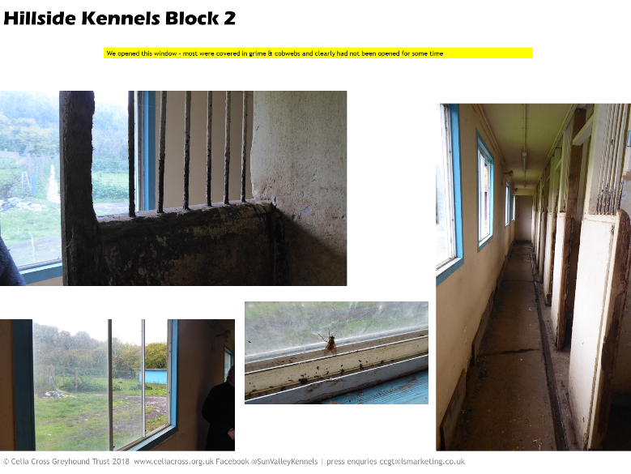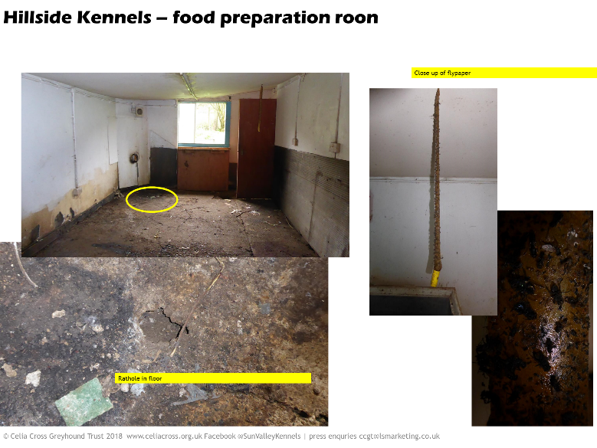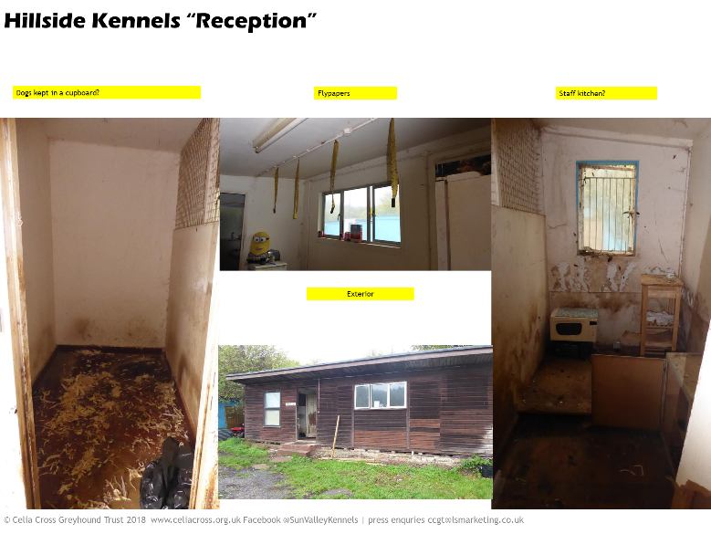

Images and videos can be downloaded from <https://www.celiacross.co.uk/hillside-resources>

The [disgusting condition of the kennels upon entry on the day of completion](https://www.facebook.com/janeythompson/videos/10156084310148869/) call into question whether the greyhound racing industry

* really do put welfare at the heart of everything they do
* are able to inspect and licence kennels effectively

Or is it in fact time to call for the industry to be phased out if this is how it allows dogs to be treated. The industry is self-regulated by the Greyhound Board of Great Britain (GBGB). The GBGB failed to honour an agreement with the Government and obtain UKAS accreditation for trainer's kennels by December 2017.

## Hillside Kennels – a legacy of neglect and abuse

For the second time in seven years, CCGT have been [shocked, angry and upset by the condition of these kennels](https://www.facebook.com/janeythompson/videos/10156084332588869/) where greyhounds had been living. Despite being told the kennels had been cleaned prior to the sale, you will see from the photo and video footage that both the kennels and the staff accommodation are filthy. In fact the rubbish removal firm said they would not their send staff back to the premises without wearing protective clothing. Staff and volunteers who’ve visited the site can all attest to the overwhelming stench of ammonia.

There are three kennel blocks – one of 20 double kennels, one of 24 single kennel and a third of 8 double kennels. None of these kennels have outdoor runs.

* Distressed dogs have chewed away at the doors and bars – leaving some with broken, exposed wire.
* Walls have deep scratches from the dogs and deeply ingrained stains from never being scrubbed.
* Many of the windows in the corridors don’t open - these blocks must have been unbearably hot and stinking in this summer’s heatwave.
* Empty drug blister packs of [Norethisterone](http://www.gbgb.org.uk/norethisterone.aspx) are strewn on the floor of the food preparation area

Jane Thompson CCGT Kennel Manager and Trustee says

“Greyhounds were housed in these horrific conditions right up to the weekend. *The only consolation I have is that no trainer or kennel hand will ever exploit another racing greyhound on this site ever again.*”

Despite being refurbished under new ownership in 2012, it is clear that the kennels have suffered years of neglect by the onsite staff under the management of [Tony Taylor](http://www.gbgb.org.uk/document/205).

The third small block has no windows and is by far in the worst condition. Although the GBGB claim this block was unoccupied and had been condemned several years ago, CCGT believe it has been occupied as evidenced by soiled bedding and expired dates on items left there.

Under the previous ownership, the kennels were abandoned with dogs in residence when the trainer Tony Lucas fled the country. You can still view the [London Tonight news report which aired 20 August 2011 here.](https://youtu.be/Cg8A5X03E_I)

## The fate of the greyhounds who lived in this squalor

Sadly Tony Taylor who has a BAGS contract with Brighton and Hove track has moved back with over 60 dogs to his previous Keston kennels which we believe had been condemned prior to his move to Hillside in 2012. These dogs will continue to race with a 1 in 3 chance of injury and 1 in 14 chance of death (based on the [GBGB 2017 injury and retirement](http://www.gbgb.org.uk/Injury%20and%20Retirement%20Data.aspx) data.

He was given a year’s notice to leave Hillside Kennels by the landowner who had finally secured planning permission for a small residence on the land. Taylor stated in a [Greyhound Star article](http://greyhoundstar.co.uk/brinkley-departure-sees-taylor-return-keston/) that the GBGB offered to give him a grant for the Hillside kennels but he now has used this £30-40K grant for his new kennels, whilst allowing the dogs at Hillside to live in squalor.

## Business as Usual

Meanwhile the CCGT continues to rescue, rehabilitate and rehome over 30 greyhounds and lurchers at their Sun Valley Kennels, adjacent to Hillside.

## Plans for the future

The condition of the kennels is much worse than expected so initial plans need to be reviewed in this light and are of course subject to securing appropriate funds.

CCGT will be asking for help from a wide variety of volunteers, professionals and companies over the coming weeks along with setting up a Go Fund Me page to contribute toward the mortgage and refurbishment costs.

## For further information

Contact [ccgt@lsmarketing.co.uk](mailto:ccgt@lsmarketing.co.uk) or call 0771 289 15556

You can also visit their Facebook page where [Jane Thompson](mailto:manager@celiacross.org.uk), Kennel Manager and Trustee has shared some initial photos and images <https://www.facebook.com/sunvalleykennels/posts/2386119578069071>

Press are invited to visit both kennels to see the appalling condition of Hillside racing kennels and how dogs are cared for at their Sun Valley Kennels.

About the Celia Cross Greyhound Trust

CCGT rescue, rehabilitate and rehome around 200 abandoned, sick or ill-treated greyhounds and lurchers each year. They were founded in 1970 after the late Celia Cross found her first abandoned greyhound which had been left to die in a disused barn. The Trust became a Registered Charity in 1993 and relies entirely on the fundraising activities of our supporters – they are independent of the racing industry and support a phased end to the greyhound racing in the UK.

**Registered Charity No. 1020383**

**Sun Valley Kennels,** Shere Road, West Clandon, Guildford Surrey, GU4 8SH, 01483 222832

[**info@celiacross.org.uk**](mailto:info@celiacross.org.uk) ●[**www.celiacross.org.uk**](http://www.celiacross.org.uk) ● **Twitter:** [**@celiacross**](https://twitter.com/celiacross)● Facebook[**@Sunvalleykennels**](http://www.facebook.com/sunvalleykennels)